**DUAL AXIS SOLAR TRACKING SYSTEM**

**A Project Report**

Submitted in partial fulfilment of the  
requirements for the award of the Degree of

**BACHELOR OF SCIENCE (INFORMATION TECHNOLOGY)**

**By**

**VAIBHAV KUMAR**

Seat Number: 18302A0023

**Under the esteemed guidance of**

**Mr. Laxmikant Manchekar**

**Assistant Professor, Department of Information Technology**



**DEPARTMENT OF INFORMATION TECHNOLOGY**

**VIDYALANKAR SCHOOL OF INFORMATION TECHNOLOGY**

**(Affiliated to University of Mumbai)**

**MUMBAI, 400 037**

**MAHARASHTRA**

**2020 - 2021**

**VIDYALANKAR SCHOOL OF INFORMATION TECHNOLOGY**

**(Affiliated to University of Mumbai)**

**MUMBAI-MAHARASHTRA-400037**

**DEPARTMENT OF INFORMATION TECHNOLOGY**



**CERTIFICATE**

This is to certify that the project entitled, **"DUAL AXIS SOLAR TRACKING SYSTEM “** is bonafide work of **VAIBHAV KUMAR** bearing Seat No: 18302A0023 submitted in partial fulfilment of the requirements for the award of degree of BACHELOR OF SCIENCE in INFORMATION TECHNOLOGY from University of Mumbai.

**Internal Guide Coordinator**

**Internal Examiner External Examiner**

**Date:**

**College Seal Principal**

**ABSTARCT**

The dual axis solar tracker actively tracks the sun and changes its position accordingly to maximize the power output. The designed tracking system consists of sensors, microcontroller operated control circuits to drive servo motors accordingly towards sun’s position and consume and utilise most of the solar energy throughout the day.

**ACKNOWLEDGEMENT**

We would like to express our special thanks and gratitude to ur project guide **Mr. Laxmikant Manchekar** for guiding us to do the project work on time and giving us all support and guidance, which made complete our project duly. We are extremely thankful to her for providing such nice support and guidance.

We are also thankful for and fortunate enough to get constant encouragement, support and guidance from the teachers of information Technology who helped us in successfully completing our project work.

**DECLARATION**

I hereby declare that the project entitled, “**Dual Axis Solar Tracking System “** done at Vidyalankar School of Information Technology, has not been in any case duplicated to submit to any other universities for the award of any degree. To the best of my knowledge other than me, no one has submitted to any other university.

The project is done in partial fulfillment of the requirements for the award of degree of **BACHELOR OF SCIENCE (INFORMATION TECHNOLOGY)** to be submitted as final semester project as part of our curriculum.

Name and Signature of the Student

**TABLE OF CONTENTS**

Contents

1.1 Background 8

1.2 Objectives 9

1.3 Purpose, Scope and Applicability 9

1.3.1 Purpose 9

1.3.2 Scope 9

1.3.3 Applicability 10

Technical Feasibility Study 10

2.1 Survey of Technologies 11

3.1 : Problem Definition 19

3.2 Requirement Specification 21

3.3 Planning and Scheduling 22

3.4 Software and Hardware Requirement 23

3.4.1.Software 23

Arduino IDE 23

3.4.2 Servo library 24

3.4.3 Hardware Requirement 24

Arduino UNO 24

Solar Panel 25

LDR’s Sensors 26

Servo motors 27

LCD 28

USB Cable 28

Male to Female wires, Wires 29

Wires 29

4.1 Block diagram 30

4.2 Circuit diagram 30

4.3Activity diagram 31

4.4 Sequence diagram 32

4.5 Use case diagram 33

4.6 Data flow Diagram 34

**List of Figures**

Figure 1:Solar Panel 8

Figure 2: Arduino UNO 9

Figure 3: LDR Sensor 10

Figure 4: LCD Display 11

Figure 5: Servo Motor 12

Figure 6 : Arduino UNO 13

Figure 7: Simulation Output 15

Figure 8: SIngle axis Solar Tracking System 17

Figure 9: Dual Axis Solar tracking system diagram 17

Figure 10: Gannt chart 20

Figure 11 : Arduino IDE 21

Figure 12: Arduino UNO 23

Figure 13 : Solar Panel 24

Figure 14 : LDR's Sensors 25

Figure 15 : Servo Motor 26

Figure 16 : LCD Display 27

Figure 17:USB cable 27

Figure 18: Jumper wires 28

Figure 19:Wires 28

Figure 20:Block Diagram 29

Figure 21: Circuit Diagram 30

Figure 22:Activity Diagram 31

Figure 23: Sequence Diagram 32

Figure 24: Use Case 33

Figure 25 : Data Flow 34

**CHAPTER 1: INTRODUCTION**

## 1.1 Background

* The use of non-renewable energy sources and the ozone depleting substances is a developing worry of the world. Thus, the innovative work of elective sources are making down the expenses related with sustainable power sources.
* PV creation is the best case of these exponential developing rates at the most recent years. Be that as it may, the yield control gave through the photovoltaic change process relies upon sun based lighting, and the day by day .
* Keeping in mind the end goal of this project shows the advancement of a minimal effort, sunlight based tracker with low power utilization.
* The work encloses the outline, development, get together of the whole mechanical structure, electrical frameworks and gadgets and the elaboration of the control rationale in charge of all the development of the module to look through the situation of greatest sun based lighting
* The following is done using LDR sensors in charge of giving the info flag to a microcontroller. The PV board pivots consequently in view of the sun radiance the day while during the evening, the board stays in a flat position to ensure the mechanical structure against severe climate.

## 1.2 Objectives

* To design and fabricate a dual axis PV (photovoltaic) system that tracks the sun path.
* Solar tracking systems repeatedly orient photovoltaic panels towards the sun and can help maximize your investment in PV system.
* There is only one time investment which provides higher efficiency and flexibility on dependency.

# 1.3 Purpose, Scope and Applicability

## 1.3.1 Purpose

* The main goal of this project is to present a control system which will cause better position of Photo voltaic (PV) array with sun light and to harvest solar power. The project system changes its direction in two axis to trace the coordinate of sunlight by detecting the difference between position of sun and panel.

## 1.3.2 Scope

* The solar project is done using two servo motors. We have used servo motors by the fact that the motor is fast, can sustain high torque, has precise rotation within limited angle and does not produce any noise.
* The Arduino UNO and Arduino IDE was utilized for the coding. In the tropics, the sun position shifts significantly during specific seasons. The design of an input stage that enables conversion of light into a voltage by the light dependent resistors( LDRs).
* The servo motors utilizes this to turn the solar panel to a position in the direction of the sunlight to capture maximum amount of solar rays to generate more amount of energy .

## 1.3.3 Applicability

### Technical Feasibility Study

**Features of Arduino UNO :-**

* Input Voltage (recommended): 7-12V
* Open source
* Easy to use
* Operating Voltage: 5V
* Digital I/O Pins: 14
* Analog Input Pins: 6
* Flash Memory: 32 KB
* Clock Speed: 16 MHz

**Why not using any other board ?**

**Arduino IDE**

 Arduino (IDE) Integrated Development Environment, it is a cross-platform application can be run in  Windows, macOS, Linux , that is written in functions from C and C++. The IDE is used to write and upload programs to Arduino like boards

**Chapter 2: Technical Feasibility**

# 2.1 Survey of Technologies

BRIEF ABOUT EACH COMPONENTS

* Solar cell
* Arduino uno
* LDR
* LCD
* Servo Motor
* Temperature sensor

SOLAR CELL

A photovoltaic cell, regularly known as a solar cell , is the invention utilized for conversion of sun oriented specifically into electrical power. The photovoltaic cell is a non mechanical gadget made of silicon amalgam. One cell can however deliver just 1 or 2 watts that isn't sufficient for generally machines. Execution of a photovoltaic cluster relies upon daylight. Climatic conditions like mists and mist essentially influence the measure of sun oriented vitality that is gotten by the exhibit and in this manner its execution. 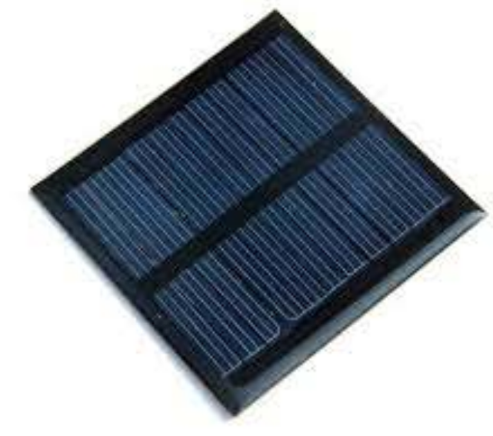

Figure 1:Solar Panel

ARDUINO UNO

The Arduino Uno is a microcontroller board in light of the ATmega328 . It has 14 computerized input/yield pins (of which 6 can be utilized as PWM yields), 6 simple information sources, a 16 MHz artistic resonator, a USB association, a power jack, an ICSP header, and a reset catch. It contains everything expected to help the microcontroller; basically interface it to a PC with a USB link or power it with an AC-to-DC connector or battery to begin.

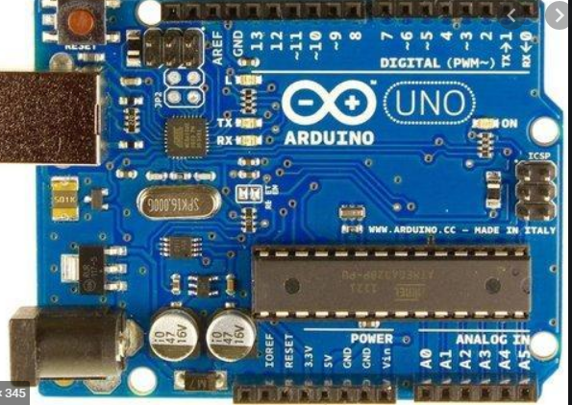

Figure 2: Arduino UNO

LDR (LIGHT DEPENDENT RESISTER)

The least difficult optical sensor is a photon resistor or photocell which is a light touchy resistor these are made of two kinds, cadmium sulphide (CdS) and gallium arsenide (GaAs). The sun tracker framework outlined here utilizations two cadmium sulphide (CdS) photocells for detecting the light.

The photocell is a latent part whose protection is contrarily relative to the measure of light power coordinated towards it. It is associated in arrangement with capacitor. The photocell to be utilized for the tracker depends on its dim protection and light immersion protection.

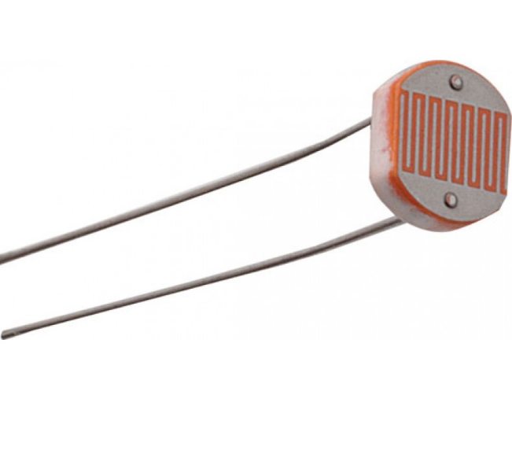

Figure 3: LDR Sensor

LCD (LIQUID CRYSTAL DISPLAY)

Fluid gem show screen is an electronic show module and locate an extensive variety of uses since they are effortlessly programmable; have no restriction of showing unique and even custom characters (dissimilar to in seven portions), live lines etc, Character and graphical LCD's are most regularly utilized. Character LCD's showcases characters, numbers, unique characters ASCII character and so on. A 16x2 LCD implies it can show 16 characters for every line and there are 2 such lines.

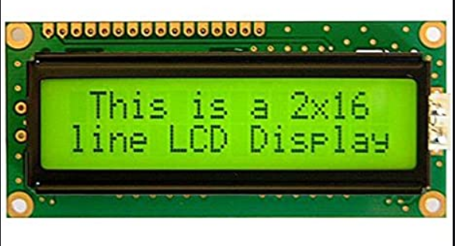

Figure 4: LCD Display

Servo motor

A servomotor is a rotary actuator or linear actuator that allows for precise control of angular or linear position, velocity and acceleration. It consists of a suitable motor coupled to a sensor for position feedback. It also requires a relatively sophisticated controller, often a dedicated module designed specifically for use with servomotors.

Servomotors are not a specific class of motor, although the term *servomotor*is often used to refer to a motor suitable for use in a closed-loop control system.

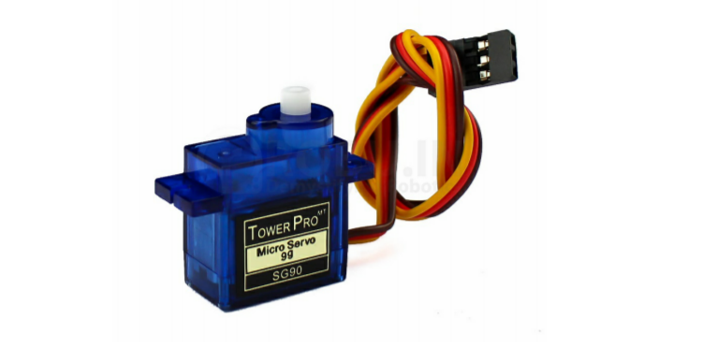

Figure 5: Servo Motor

**Should I start with Arduino UNO or Raspberry Pi?**

The Arduino is simpler, harder to 'break' or 'damage' and has much more learning resources at this time for beginners. With the Pi you have to learn some Linux as well as programming—such as Python. ... While the Raspberry Pi shines in software application, the Arduino makes hardware projects very simple.

Arduino is a great tool for developing interactive objects, taking inputs from a variety of switches or sensors and controlling a variety of lights, motors and other outputs. Arduino projects can be stand-alone or they can be connected to a computer using USB.

**Arduino UNO:**

* An Arduino is a microcontroller motherboard. A microcontroller is a simple computer will run one program at a time, over and over again. It is very easy to use.
* Arduino Uno is the most standard board available and probably the best choice for a beginner.
* Its biggest advantage is that we connect the board to the computer via a USB cable which does a dual purpose of supplying power and acting as a Serial port to interface the Arduino and the computer.

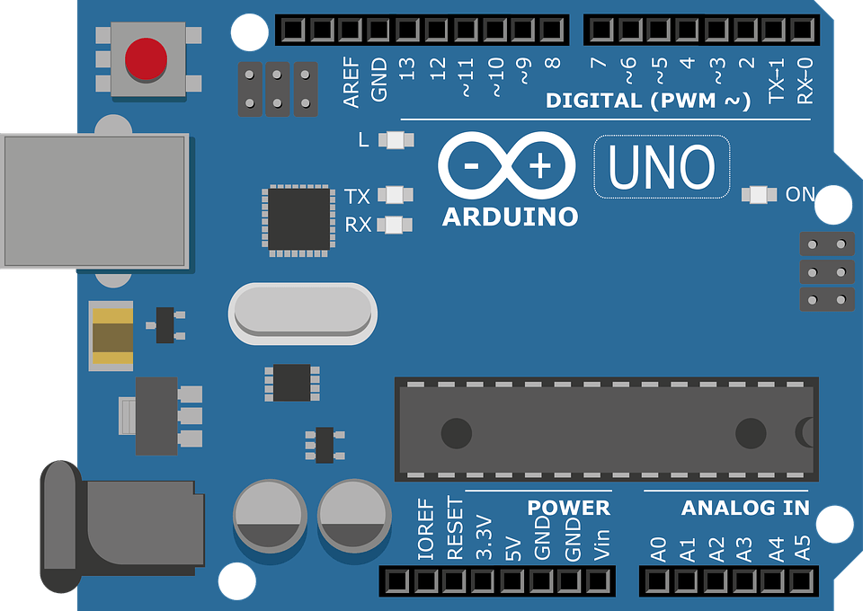

Figure 6 : Arduino UNO

**Arduino IDE :**

* Arduino (IDE) Integrated Development Environment, it is a cross-platform application can be run in  Windows, macOS, Linux , that is written in functions from C and C++. The IDE is used to write and upload programs to Arduino like boards
* Most microcontroller systems are limited to Windows. Simple, clear programming environment - The Arduino Software (IDE) is easy-to-use for beginners and flexible enough for advanced users to take advantage of as well.

**Tinkercad :**

Tinkercad is a free, online 3D modelling program that runs in a web browser, known for its simplicity and ease of use. Since it became available in 2011 it has become a popular platform for creating models for 3D printing as well as an entry-level introduction to constructive solid geometry in schools.

We have done a simulation on tinkercad.com by using all the components .

We have used the following components in the simulation and done the connections accordingly

* Arduino uno
* Servo motors
* LDR’s
* Bread board
* Potentiometer

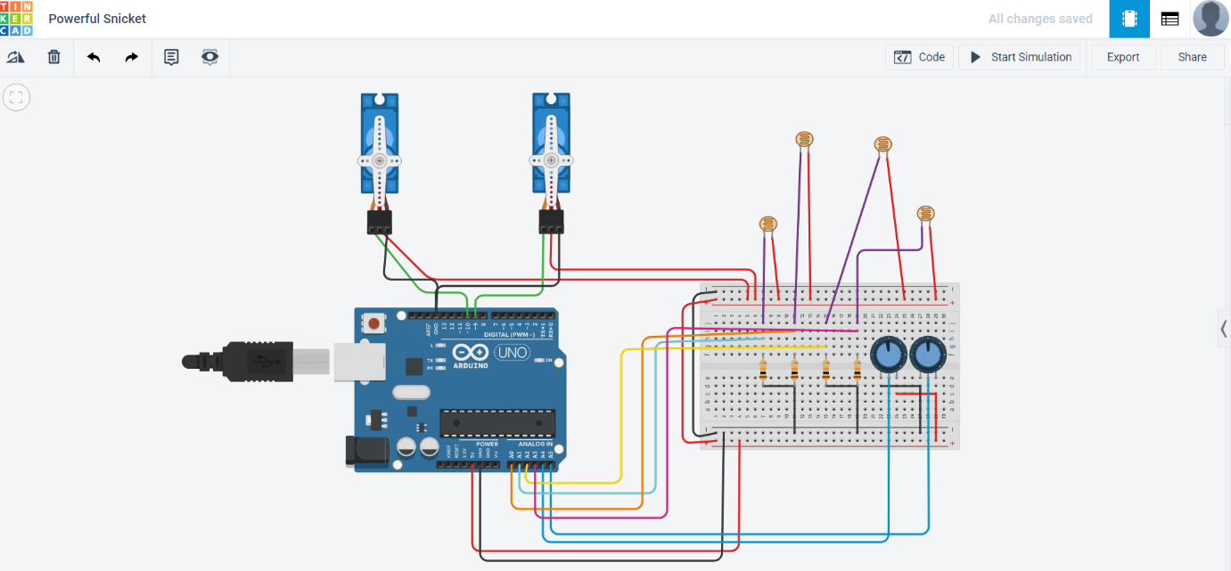

Figure 7: Simulation Output

**Chapter 3**

**Requirements and Analysis**

# 3.1 : Problem Definition

As many of we know, the normal solar tracking system is fixed at a position i.e single axis solar tracker. It can only track solar light at fixed particular angle and miss most of sunlight through out the day and also the earth follows a complex motion that consists of the daily motion and the annual motion. The daily motion causes the sun to appear in the east to west direction over the earth whereas the annual motion causes the sun to tilt at a particular angle while moving along east to west direction .

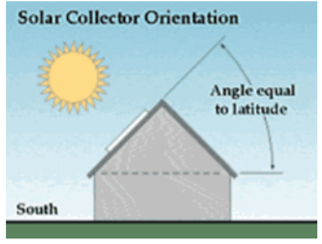

Figure 8: SIngle axis Solar Tracking System

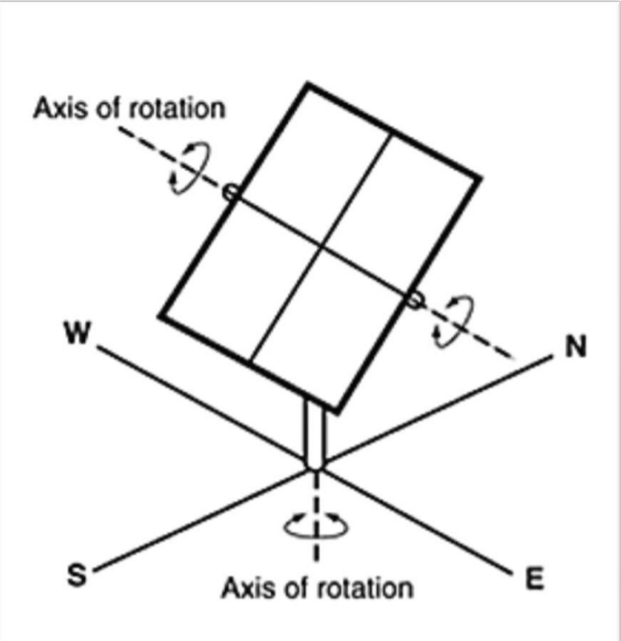

Figure 9: Dual Axis Solar tracking system diagram

The effectiveness of a solar tracker and PV technology in general, is directly correlated to the amount of sunlight that it is being exposed to; its power output is dependent on the amount of light that reaches the solar cell. The main goal is to keep solar PV panel perpendicular to the sun throughout the day in order to increase the energy generation. Dual axis solar tracking system can be an effective way to increase the efficiency of solar cells. The devastating problem on both biotic and abiotic components of our home (i.e. pollution) can be reduced by using solar energy as the major source for power generation. The natural gift like fossil fuels, woods, etc. which are limited in amount can be saved from crisis and extinction. For people, due to its more efficiency and less harmful impacts dual axis solar tracking system might be good decision for the intermediate future. So, this project can practically demonstrate effect of this variation to people.

# 3.2 Requirement Specification

* + - Microcontroller: Simply connect it to a computer with a USB cable or power it with a AC-to-DC adapter or battery to get started. You can tell your board what to do by sending a set of instructions to the microcontroller on the board.
    - Sensor: A sensor is a device, module, or subsystem whose purpose is to detect events or changes in its environment and send the information to other electronics, frequently a computer processor.
    - Motor: A motor is a device that changes a form of energy into mechanical energy to produce motion.
    - Laptop: A laptop, also called a notebook computer or simply a notebook, is a small, portable personal computer with a "clamshell" form factor, having , typically, a thin LCD or LED computer screen mounted on the inside of the upper lid of the "clamshell" and an alphanumeric keyboard on the inside of the lower lid.
    - Wires: The purpose of the wires in a series circuit is to allow the electricity to flow from one device to the next. Wire is used to carry the flow of electrons.

# 3.3 Planning and Scheduling

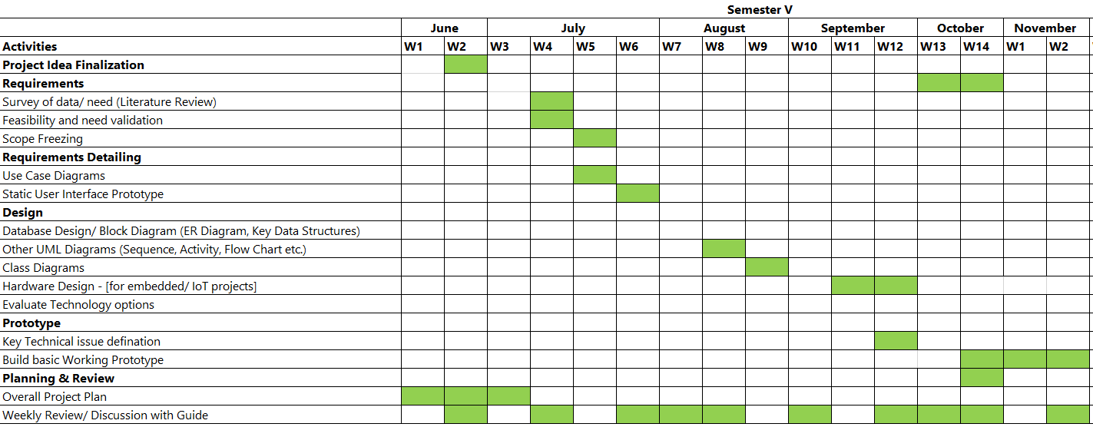

Figure 10: Gannt chart

# 3.4 Software and Hardware Requirement

## 3.4.1.Software

### Arduino IDE

The Arduino Integrated Development Environment is a cross-platform application that is written in functions from C and C++. It is used to write and upload programs to Arduino compatible boards, but also, with the help of third-party cores, other vendor development boards. It is quite simple to use and compile code . The Arduino IDE supplies a [software library](https://en.wikipedia.org/wiki/Software_library) from the [Wiring](https://en.wikipedia.org/wiki/Wiring_(development_platform)) project, which provides many common input and output procedures.

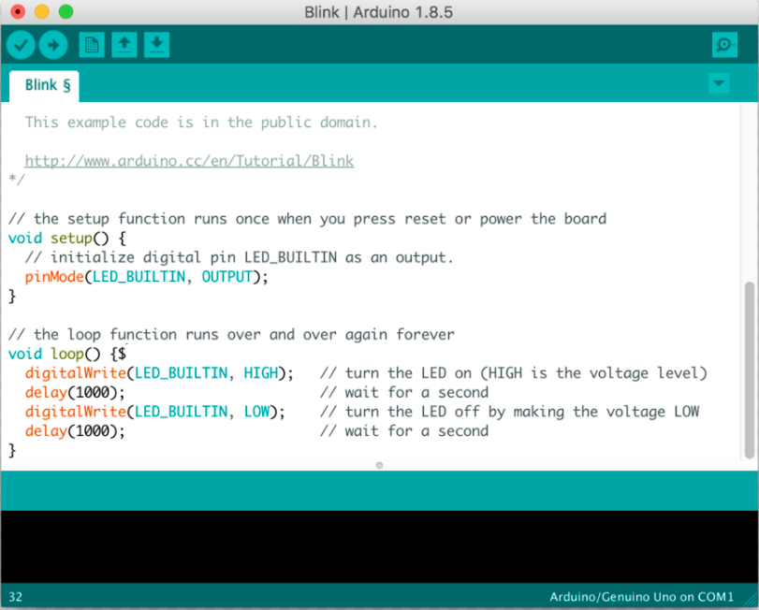

Figure 11 : Arduino IDE

## 3.4.2 Servo library

Allows Arduino/Genuino boards to control a variety of servo motors.  
This library can control a great number of servos. It makes careful use of timers: the library can control 12 servos using only 1 timer. On the Arduino Due you can control up to 60 servos but we are using only two motors .

## 3.4.3 Hardware Requirement

### Arduino UNO

The Arduino Uno is a microcontroller board in light of the ATmega328 . It has 14 computerized input/yield pins (of which 6 can be utilized as PWM yields), 6 simple information sources, a 16 MHz artistic resonator, a USB association, a power jack, an ICSP header, and a reset catch. It contains everything expected to help the microcontroller. It is basically interface it to a PC with a USB link or pwer it with an AC-to-DC connector or battery to begin.

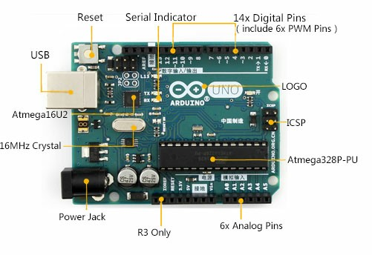

Figure 12: Arduino UNO

### Solar Panel

The term solar panel is used **colloquially** for a photo-voltaic (PV) module.

A PV module is an assembly of photo-voltaic cells mounted in a framework for installation. Photo-voltaic cells use sunlight as a source of energy and generate direct current electricity. A collection of PV modules is called a PV Panel, and a system of Panels is an Array. Arrays of a photovoltaic system supply solar electricity to electrical equipment. Photovoltaic modules use light energy (photons) from the Sun to generate electricity through the photovoltaic effect.

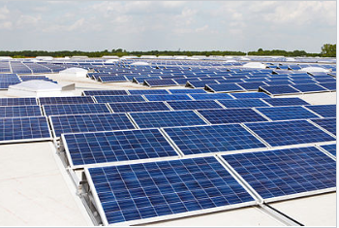

Figure 13 : Solar Panel

### LDR’s Sensors

A photoresistor (acronym LDR for Light Decreasing Resistance, or light-dependent resistor, or photo-conductive cell) is a passive component that decreases resistance with respect to receiving luminosity (light) on the component's sensitive surface.

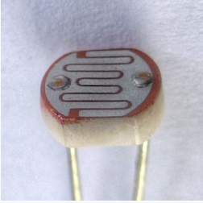

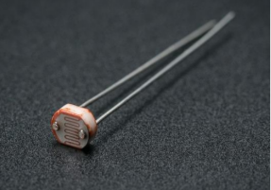

Figure 14 : LDR's Sensors

### Servo motors

The servo motor is a closed-loop mechanism that incorporates positional feedback in order to control the rotational or linear speed and position. The motor is controlled with an electric signal, either analog or digital, which determines the amount of movement which represents the final command position for the shaft. Servos are mainly used on angular or linear position and for specific velocity, and acceleration.

ADVANTAGES OF SERVO MOTOR:

* If a heavy load Is placed on the motor, the driver will increase the current to the motor coil as it attempts to rotate the motor. Basically, there is no out-of-step condition.
* High-speed operation is possible.

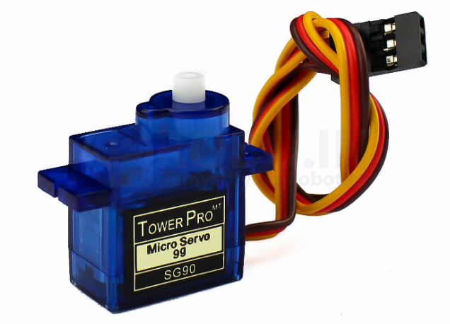

Figure 15 : Servo Motor

### USB Cable

USB cable is used to insert the code written in Arduino IDE in the Arduino

Board and this cable is inserted into the laptop or desktop.

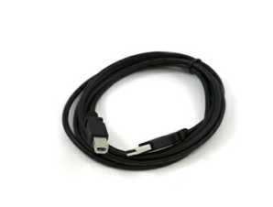

Figure 17:USB cable

### Male to Female wires, Wires

Male to female jumper wires

Jumper wire male to female, used in connecting female header pin of any development board (like Arduino) to other development board having male connector. In this one end of the wire is male connector and other one is female.

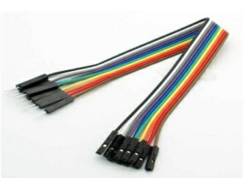

Figure 18: Jumper wires

### Wires

A wire is a single, usually cylindrical, flexible strand or rod of metal. Wires are

used to bear mechanical loads or electricity and telecommunications signals. Wire is commonly formed by drawing the metal through a hole in a die or drawplate.

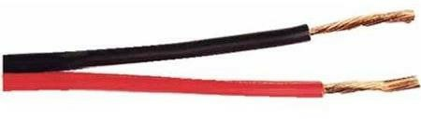

Figure 19:Wires

**Chapter 4**

# 4.1 Block diagram

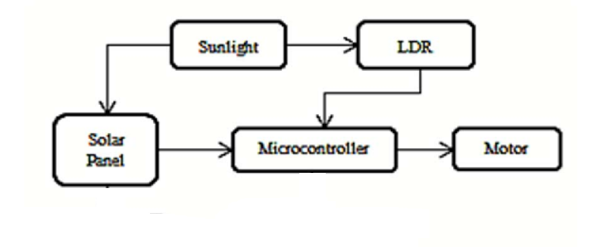

Figure 20:Block Diagram

# 4.2 Circuit diagram



Figure 21: Circuit Diagram

# 4.3Activity diagram

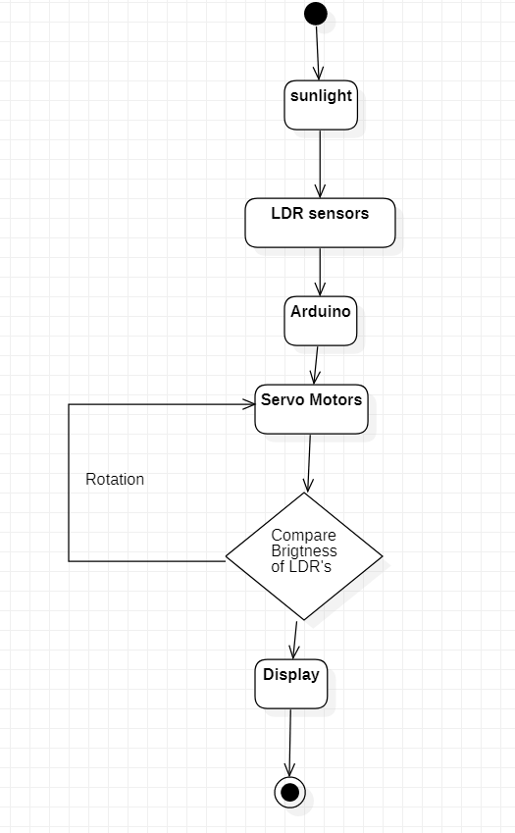

Figure 22:Activity Diagram

# 4.4 Sequence diagram

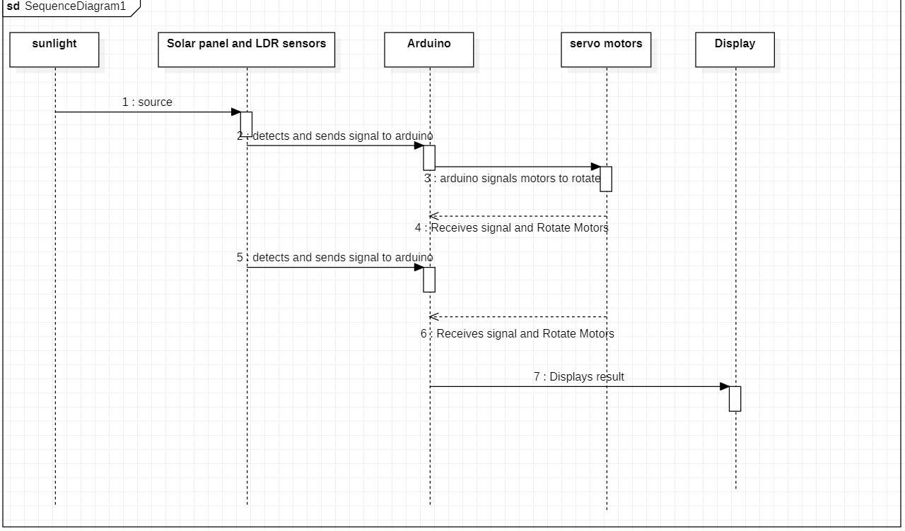

Figure 23: Sequence Diagram

# 4.5 Use case diagram

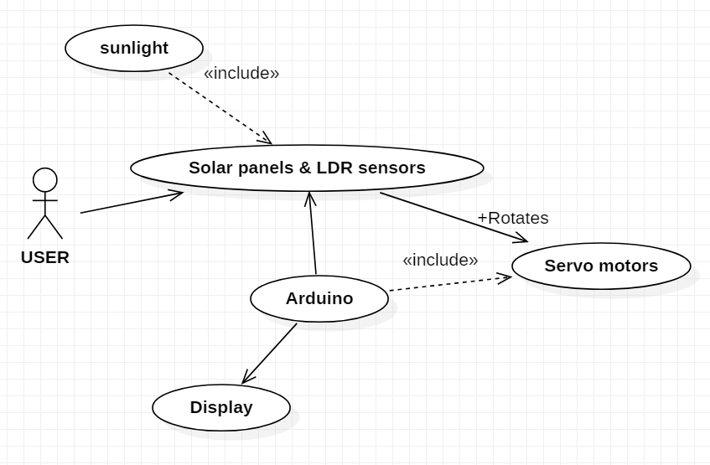

Figure 24: Use Case

# 4.6 Data flow Diagram

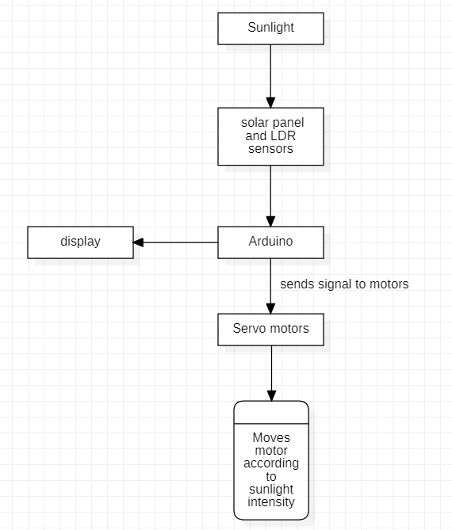

Figure 25 : Data Flow

